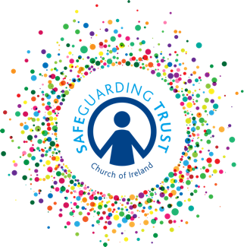
Declaration by person from abroad applying to work or volunteer in a diocese/parish in the Church of Ireland
Diocese/parish of

- Whether in your present country of residence or elsewhere, have you ever been investigated in respect of or charged with or convicted of a criminal offence or have you ever been the subject of a court order binding you over to keep the peace or have you ever been subject to criminal proceedings in which the court has found the charge or charges against you to have been proved but in respect of which the Probation Act (or any foreign equivalent thereof) has been applied, or are you at present subject to any criminal charges or criminal investigation ?

YES/NO (If yes to any of the above give details on separate sheet)

- Have you ever committed any criminal act or been engaged in any criminal conduct for which you have not been prosecuted, whether in your present country of residence or elsewhere?

YES/NO (If yes to any of the above give details on separate sheet)

- Has any court in your present or any other jurisdiction ever found you liable in civil litigation?

YES/NO (If yes give details on separate sheet)

- Have you been placed on a sex offenders’ register in your present or any other jurisdiction?

YES/NO (If Yes, give details on separate sheet)

I, the undersigned, who have applied to work / volunteer as

(office/position for which you are applying)

do hereby certify and warrant that in completing this form and in furnishing all the information contained herein or attached hereto, I am doing so in good faith, and I further certify and warrant that all such information is true and accurate and constitutes a full disclosure of all material facts known to me.

Signed

Full name (block capitals)

Date

When completed and signed, return this form to
In line with Data Protection regulations, we are committed to protecting the personal information we hold on you. By providing the information requested, you are giving us permission (consent) to use this information for Safeguarding, legal or regulatory purposes and we will use it for no other purpose without further consent unless mandated or required to do so under the Data Protection Act 2018 or equivalent legislation. If you have any questions about how we process your personal data, please contact a member of the Panel.

