………………….………………….……………….…Parish

Health and Safety Statement

Our policy with regard to Health and Safety is:

- To ensure, so far as is reasonably practical, the health and safety of all members of the Parish including staff, volunteers, parishioners, visitors, contractors and others who may visit the Parish and its associated buildings
and grounds

- To provide and maintain safe and healthy working conditions, equipment and systems of work for all our employees, contractors and volunteers

- To provide information, instruction, training and supervision for staff and volunteers to ensure they are competent to perform their duties

- To prevent accidents and cases of work related ill-health and to provide adequate control of the health and safety (H&S) risks arising from our work activities

- To implement emergency procedures – including evacuation in case of fire or other significant incident

- To ensure the safe storage and handling and use of substances

- To engage and consult with our staff, contractors and volunteers on matters affecting their health and safety

If you have a concern with regard to Health and Safety please contact a churchwarden or member of the Select Vestry.
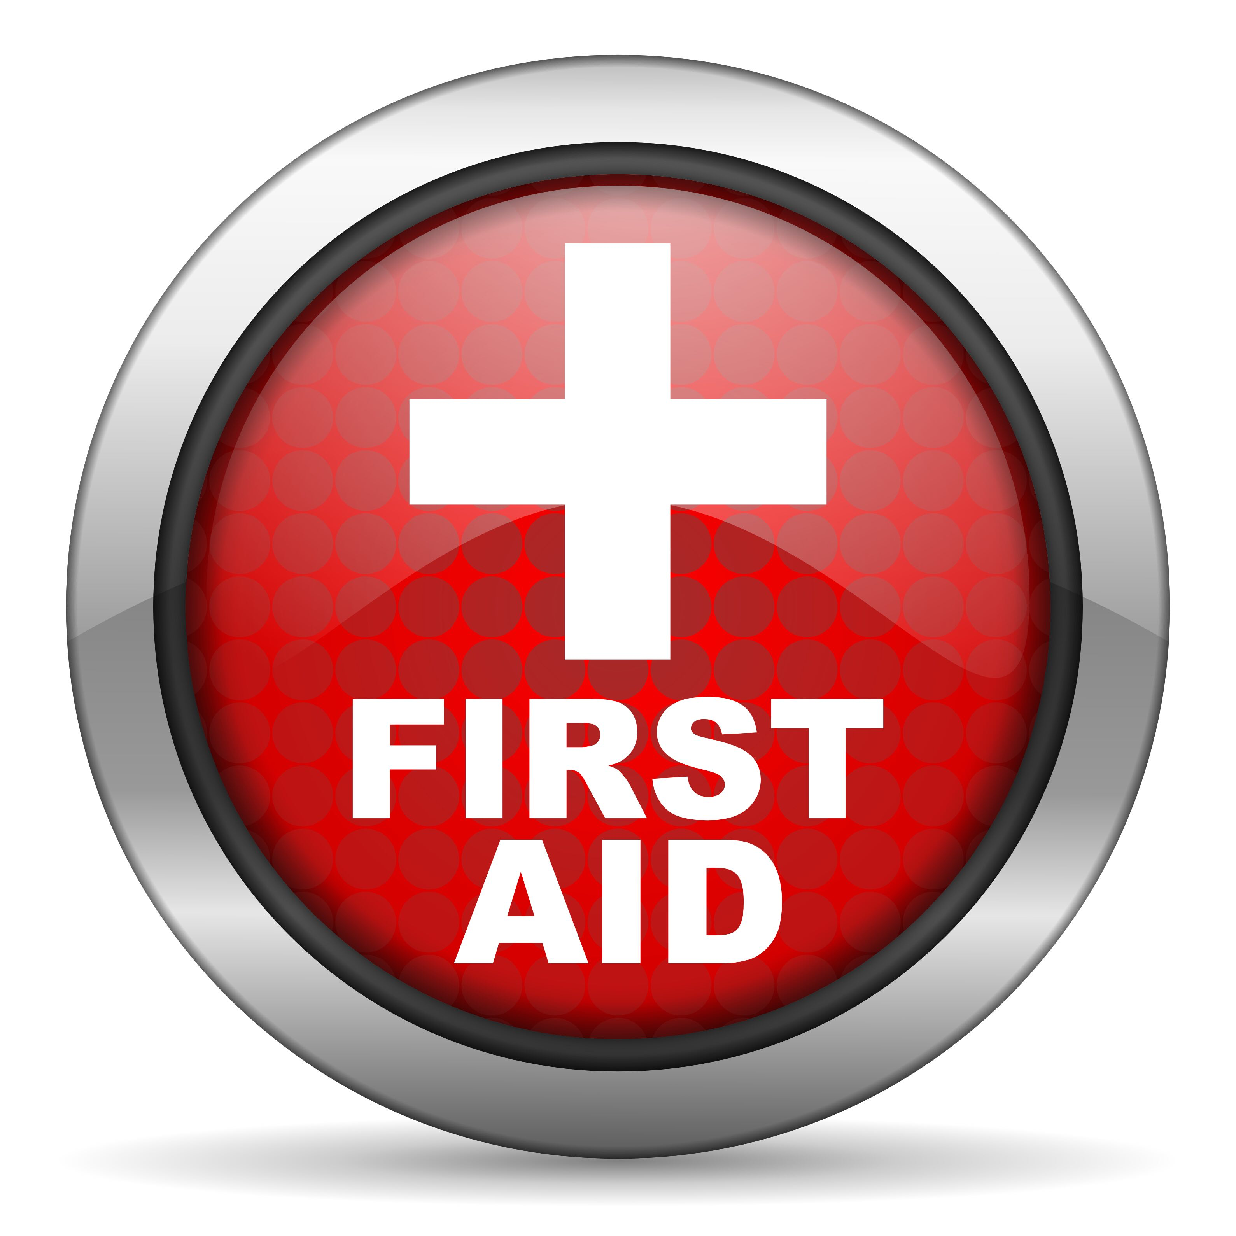

A First Aid box is located in:

___________________________________________________

