…………………Parish

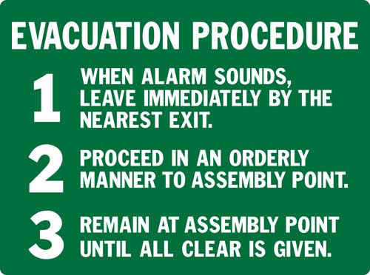

THE ASSEMBLY POINT IS LOCATED AT:

