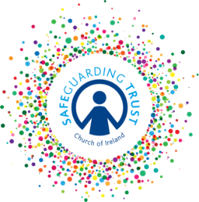
Parish of ………………
Annual Safeguarding Trust Checklist for Vestries 20….. (Yr)
 |  | YES | NO
A | Is first-aid available during all activities?
 | Is there an up-to-date first-aid kit available both on the premises and for activities away from the premises?
 | Do clergy, staff and volunteers know who the First Aider is and where they can be contacted?
 | Are all accidents and incidents recorded?
B | Do regular fire drills take place?
 | Are evacuation notices displayed informing people what to do in case of emergency?
 | Are fire appliances suitable and serviced regularly?
 | Has the local fire prevention officer visited the premises?
C | Is there a Health & Safety Statement in place that covers all parish premises?
 | Has an Annual Safety Audit been undertaken?
 | Has an Annual Health & Safety Risk Assessment of activities been undertaken?
D | Do precautions exist regarding access to premises by strangers whilst children’s activities are taking place?
E | Is the Child Safeguarding Statement displayed on all parish premises?
F | Have the panel completed their care of records checklist in past twelve months(see separate list)?
 | Have the panel, clergy, staff and volunteers completed their safety of activites checklist in the past twelve months (see separate list)?
G | Has every external organisation that involves children signed the common protocol agreement this year?
 | Has every external organisation that involves children provided the parish with a copy of their insurance and child protection policy?
H | Is there adequate and approriate insurance cover provided for all activities?

