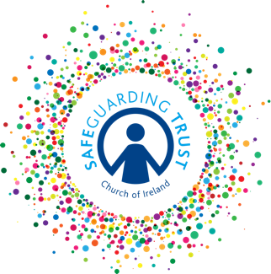
Parish of ………………….…………

Partnership with Parents Policy

In order to encourage trust and support in working with children and young people in the parish we have a policy of working in partnership with parents/guardians. This will involve consultation and information sharing regarding aspects of their child’s participation and include the parish aiming to:

- Introduce staff and volunteers to children’s parents and making them available for parents to talk to.
- Provide regular information to parents/guardians on the activities and events of your child’s group.
- Encourage parents to ask questions, make suggestions and review with us their child’s progress in the group.
- Discuss with parents any concerns that staff/volunteers have with their child.
- Provide parents’ access to the church’s various policies in relation to working with children and youth. These can be attained through the Parish Panel and include:
  - The Safeguarding Trust child protection policy
  - An anti-bullying policy
  - A communications policy
  - A social media policy
  - A complaints procedure
  - Our General Data Protection Regulations (GDPR) policy.

ADOPTED BY THE SELECT VESTRY ON (DATE):__________________________

SIGNED (CHAIR OF THE VESTRY):______________________________________

SIGNED (HON SEC OF THE VESTRY):____________________________________

(For up-to-date guidance on the Safeguarding Policy please consult https://www.ireland.anglican.org/about/safeguarding/)

