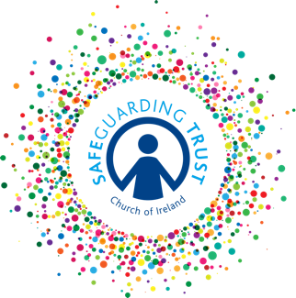
Parish of ………………….…………
Disciplinary Procedure Policy
for staff and volunteers
In addition to the Parish Code of behaviour for children and young people in parish activities all clergy, staff and volunteers are expected to adhere to the Safeguarding Trust Code of Behaviour in Part 4 of the Child Safeguarding Policy (available at https://www.ireland.anglican.org/about/safeguarding/ni-child-safeguarding)

The code of behaviour for bishops, clergy, staff and volunteers has been categorised under five headings:
• Child-centred approach;
• Best practice;
• Inappropriate behaviour;
• Physical contact;
• Health & Safety.

Clergy, Staff and volunteers should understand that:
• If they are unsure of their actions and feel they may have breached the Code of Behaviour or feel that their actions may have been misconstrued, a report should be written and submitted immediately to the leader-in-charge and / or the panel.
• Breaching the Code of Behaviour may be a serious issue that will be investigated.
• Breaching the Code of Behaviour may result in disciplinary action and ultimately dismissal if it constitutes harm/risk of harm.
It is important that if a staff member or volunteer has a concern about the behaviour of another staff member or volunteer they should report these concerns to the panel. Where the concern relates to a panel member, reports should be made to another panel member or incumbent. Where the concern relates to the incumbent, reports should be made to the bishop.

Disciplinary procedures if a volunteer is found in breach of Code of Behaviour
Each breach of the Code of Behaviour will be assessed in line with the Parish Complaints procedure above. If a volunteer is deemed to be in breach of the Code of Behaviour the leader in charge or panel member will speak to the individual volunteer. They will determine whether the volunteer should be given a warning on that occasion but will remind the volunteer of the standards expected of volunteers.

If there are further breaches of the Code of Behaviour by the volunteer following a warning, the Panel will meet with the volunteer and the Panel will ask the volunteer to resign from their position.

If a serious allegation of abuse is made against a volunteer, the Panel and Internal Review Group will follow the procedures for dealing with an allegation against a volunteer as contained in Safeguarding Trust.

Disciplinary procedures if a staff member is found in breach of Code of Behaviour
Each breach of the Code of Behaviour will be assessed in line with the complaints procedure. If a staff member is deemed to be in breach of the Code of Behaviour the disciplinary procedures in the staff member’s contract shall be followed where it is a serious incident and it warrants suspension or dismissal of the staff member. If a cleric is deemed to be in breach of the Code of Behaviour the disciplinary procedures set out in Chapter 8 of the Constitution of the Church of Ireland shall be followed where it is a serious incident and it warrants the suspension or dismissal of the cleric.

Adopted by the Select Vestry on ___________________________

Signed (Chair of vestry)__________________________________

Signed (Hon Sec of vestry)________________________________

