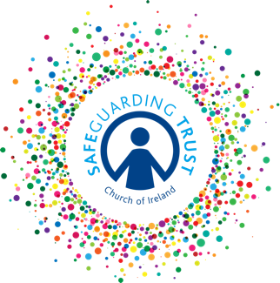
Parish of ………………….…………

Communications Policy

Good communication is essential to maintaining a positive working and learning environment. This Communication Policy is for all those involved in children’s activities and deals with communication within the parish and with parents, children and the wider community.

Means of communication:
This policy encourages the use of the most effective communications mechanism depending on context, whilst ensuring the rights of everyone involved in the communication.

Communication methods utilised:
- Personal contact
- Phone calls
- Written communication (email, letters, notes)
- Text messages including What’s app
- Social media
- Website

We shall use the above communication methods to seek to achieve the following:

The display of publicly available information on the premises and parish website (if applicable) such as:
- A Child Safeguarding Statement and contact details for the Parish Panel
- Children’s information poster with contact details of panel members.
- General information about our parish and our children’s activities.
- Contact details for relevant personnel.
- Details of where other Safeguarding Trust and other relevant policies and procedures can be accessed.

Regular communication with parents regarding:
- The staff and volunteers that will be working with their children, including contact details.
- General information about the activity their child is participating in, including meeting times, drop off, pick up, events and trips.
- Asking them to complete membership information for submitting child’s personal details as well as authorisations from parent/guardian.
- Asking them to complete consent forms for activities and trips away from the parish premises.
- The Code of Behaviour for their child’s group and the sanctions for breaching that Code of Behaviour.
- Safeguarding Trust and supporting policies through information leaflets.
- Opportunities to talk with staff and volunteers for feedback on how their child is doing and with regard to the programme itself.
- The Safeguarding Policy with regard to the use of social media to communicate with young people aged 13 years and over.
- General Data Protection Regulations policy requirements.
- How to make a complaint.
- Any concerns staff or volunteers have about their child’s welfare and safety provided it does not further endanger the child, staff, volunteers or panel members.

We shall ensure that we inform children and young people about:
- Upcoming activities.
- Their right to be protected, listened to and to have their views taken into consideration.
- Safeguarding Trust through information leaflets and verbal communication.
- Being able to talk to staff and volunteers about any concerns that they might have and any other feedback they want to offer.
- The Code of Behaviour that applies to them and the sanctions for breaching that Code of Behaviour.
- The expectations of the Safeguarding Policy with regard to their consent to be communicated with directly through social media (for over 13 years only).

All information provided by parents/guardians and children as part of this Communications Policy shall be treated with the utmost confidentiality. However, if any information pertaining to a child’s welfare and safety comes to a staff member’s or volunteer’s attention through any of these means of communication, they shall follow the relevant procedures laid out in the Safeguarding Trust.

ADOPTED BY THE SELECT VESTRY ON (DATE):__________________________

SIGNED (CHAIR OF THE VESTRY):______________________________________

SIGNED (HON SEC OF THE VESTRY):___________________________________

(For up-to-date guidance on the Safeguarding Policy please consult https://www.ireland.anglican.org/about/safeguarding/)

