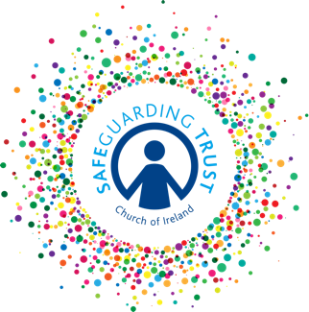
Parish of …………………..……………
Checklist for Panels and Staff and Volunteers

Safety of Activities 20….. (Yr)

This checklist should form the basis of an annual meeting of the
panel, staff and leaders in charge of each organisation.

DATE OF MEETING:_____________ SIGNED(incumbent):_________________________

 |  | YES | NO
A | Is a register kept of all those in attendance at children’s organisations?  Has a registration form been completed for each child who attends?  Is an activity consent form used for outings and residential activities?  Is parental consent sought for the taking and use of photographs?
B | Are supervision levels appropriate for children’s age, activities being undertaken etc?
C | Has each group held a fire drill in the last twelve months?
D | Do clergy/staff/volunteers talk to children about Safeguarding Trust?  Do the clergy/staff/vols provide children information leaflets to children (over 10 yrs) and make them aware of the children’s information poster?
E | Does each group have a Code of Behaviour in place for the members?  Have parents been informed of each group’s Code of Behaviour and sanctions?
F | Have any issues arisen in any group in relation to content of activities?  Has each group adequate resources for their activities for the next twelve months?
G | Has adequate planning taken place for group outings/trips?
H | Has any group taken photographs of children? Have they been stored securely?
I | Does any group use social/digital media to contact children?  Has parental permission been sought?  If there is a social networking site, how it is monitored?
J | Are there any other issues which volunteers/staff have had to deal with which they need help and support with?

