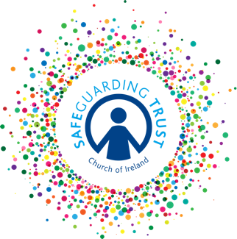
Parish of ……………………………

SAFEGUARDING TRUST
Panel Notice for Parish Premises
“IT IS THE POLICY OF THE CHURCH OF IRELAND TO SAFEGUARD
ALL CHILDREN SHARING IN ITS MINISTRY AND TO PROTECT
THEM FROM ALL FORMS OF HARM AND ABUSE.”

The incumbent, select vestry, staff and volunteers are committed to uphold good practice in the parish's ministry with children.

Should you have a concern, suspicion or allegation regarding child welfare in the parish please contact a member of the parish panel.

1. ………………………………………….. Tel ……….……………….

2. ………………………………………….. Tel ……….……………….

3. ………………………………………….. Tel ……….……………….

The duty social worker or local area manager may be contacted at the local Gateway Team .

Belfast Health and Social Care Trust (covering local council areas of Belfast and Castlereagh): Tel: 028 9050 7000 (9am-5pm) or 028 9504 9999 at all other times.

South Eastern Health and Social Care Trust (covering local council areas of N’ards, Down, North Down and Lisburn): Tel: 0300 100 0300 (9am-5pm) or 028 9056 5444 at all other times.

Southern Health and Social Care Trust (covering local council areas of Dungannon, Armagh, Craigavon, Banbridge and Newry and Mourne); Tel 028 3741 5285. (9am-5pm) or 028 9504 9999 at all other times.

In emergency contact the local PSNI station

