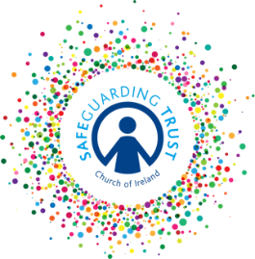
Parish of ………………………….…
Internal Report Form –for reporting concerns on child welfare
PLEASE SEE PART 7 OF THE SAFEGUARDING TRUST POLICY
What might constitute a concern about a child? A concern relates to the possibility of a child suffering harm. Indicators of this might include:
- Sudden, unexplained or worrying changes in behaviour.
- Physical signs or symptoms that may be indicative of abuse (emotional, sexual, physical or neglect).
- Worry remarks made by a child.
- A situation where a child is exposed to potential risk of harm

All concerns should be recorded and reported to the Parish Panel, even if they seem insignificant, whether they relate to situations internal or external to the parish. For instance, concerns connected to a family or school situation should be noted as well as concerns related to your organisation.

You may not be able to complete all of the fields in this form and not all sections will be relevant to a particular concern.
NB: A staff member or volunteer should, in the first instance, report to a panel member who will report to a statutory agency

.

Name of person Date of birth:

Address and phone number

What is the nature of the concern? Outline the circumstances in which you became aware of it.

If a child has made a disclosure of abuse, state the name of the person he/she spoke to with the date, time and place
If a child has made a disclosure of abuse, record as precisely as possible what the child actually said.

If an adult has expressed concern in relation to the safety of a child, record if he/she is expressing his/her own worries or passing on those from another adult. Record the concerns and ask him/her to confirm that the details as written are correct.

Have possible signs or indicators of harm been identified? YES/NO
If yes, please outline below

Record the name(s) of the person(s) alleged to have harmed the child.

Signed by staff member/volunteer Date

FOR PANEL USE ONLY
Report received by

Signed Date

