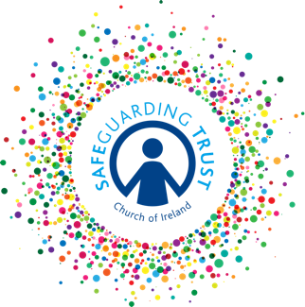
Parish of …………….…………

Declaration by person from abroad applying to work
or volunteer in a parish in the Church of Ireland

- Whether in your present country of residence or elsewhere, have you ever been investigated in respect of or charged with or convicted of a criminal offence or have you ever been the subject of a court order binding you over to keep the peace or have you ever been subject to criminal proceedings in which the court has found the charge or charges against you to have been proved but in respect of which the Probation Act (or any foreign equivalent thereof) has been applied, or are you at present subject to any criminal charges or criminal investigation ?

YES/NO (If yes to any of the above give details on separate sheet)

- Have you ever committed any criminal act or been engaged in any criminal conduct for which you have not been prosecuted, whether in your present country of residence or elsewhere?

YES/NO (If yes to any of the above give details on separate sheet)

- Has any court in your present or any other jurisdiction ever found you liable for a civil offence?

YES/NO (If yes give details on separate sheet)

- Have you been placed on a sex offenders’ register in your present or any other jurisdiction?

YES/NO (If Yes give details on separate sheet)

I, the undersigned, who have applied to work / volunteer as

_________________________________________________________________
(office/positions for which you are applying)

do hereby certify and warrant that in completing this form and in furnishing all the information contained herein or attached hereto, I am doing so in good faith and I further certify and warrant that all such information is true and accurate and constitutes a full disclosure of all material facts known to me.

Signed………………………………………….

Full name (block capitals) ………………………………………….

Date……………………………………………

When completed and signed, return this form to the Parish Panel

