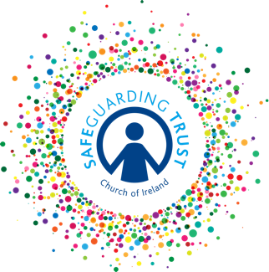

Declaration of Acceptance of Safeguarding Trust and a
‘Duty to Care’

Parish of ……………………………………………………………………………………….

Declaration

I have attended a training event on (insert date) ______________________ at (insert venue) ________________ which has introduced me to the Church of Ireland Safeguarding Trust and the recommended procedures to be followed when working with children have been explained to me.

I acknowledge receipt of the relevant sections of Safeguarding Trust and declare I will uphold the same in the position I have accepted with (name of group/parish)

I further state that I shall exercise a duty to care for any children in my charge.

Name (print)

Signed

Date

NB This declaration is to be retained by the parish panel.

