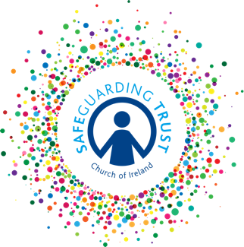

Consent form for photographs or recorded images

The parish of / diocese of: ____________________________________________________

recognises that the need to ensure the welfare and safety of all children. In accordance with our child protection policy, Safeguarding Trust, parents/guardians and child (13 or over) are asked to sign a consent form for the taking of photographs and recorded images on the understanding that photographs and recorded images may be used in a range of hardcopy, online publications and social media by the parish and/or the diocese. They may also be retained for continued use by the parish/diocese.

Parent/Guardian consent

I consent to the photographing or recording of

Name of child: ______________________________________________________________

while involved in activities run by:

Name of parish/diocese: ______________________________________________________________

Yes No

Signed: _____________________________ Date: _____________________

Child’s consent (if 13 or over)

I consent to photographing or recording of my involvement in activities run by:

Name of parish/diocese: _______________________________________________________________

Yes No

I understand that my consent may be withdrawn at any time.

Signed: _____________________________ Date: _____________________

(This consent may be incorporated into the Membership Registration Form -
insert section reference)

