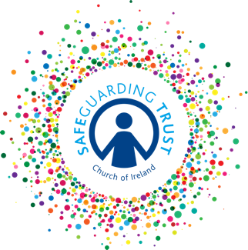

Guidelines for a code of behaviour for members

A code of behaviour for members helps to explain children’s rights and responsibilities when taking part in a group’s activities. For a code of behaviour to work best, children need to be able to develop the code for themselves, with the assistance of clergy/staff/volunteers.

Codes of behaviour have been shown to help children to develop their sense of fair play and mutual respect and will help to create a safe, secure environment and an atmosphere where children will feel that they can confide in the leaders. When children ‘own’ the code, they will generally protect and support it.

It is recommended that at the commencement of the group’s year a code of behaviour be drawn up with the members’ participation. While it is recognised that discipline may seem at times to be restrictive to children it is best enforced with their agreement and therefore the members should also be involved with deciding what sanctions should be associated with the code of behaviour.

An effective code of behaviour should contain the following elements:

- A description of the rights and responsibilities of all members of the group (i.e. respecting view and feelings of other members, right to express opinions, right to be heard/listened to)
- A description of the ways in which the group encourages and recognises good behaviour (i.e. reward system)
- A description of unacceptable/inappropriate behaviour (i.e. alcohol consumption, smoking, physical abuse, verbal abuse, destruction or damage of property or equipment, misuse of any substance)
- Mechanisms for achieving a supportive culture and positive environment (i.e. leaders willing to listen to children, involvement of children in decision making)
- Strategies to embrace diversity and difference within the group (i.e. respecting others’ opinions, not excluding anyone)
- Strategies for the prevention of bullying and other serious misbehaviour and processes for managing conflict (see Anti-Bullying policy template)

Sanctions should contain the following elements:
- Issuing an apology
- Loss of privileges
- Parents/guardians being informed of the breach of code
- Leaving the group for a period and/or for good.

Once the Code of Behaviour and sanctions have been agreed by the members of the group, a copy of it should be issued to each child and their parents/guardians for them to sign.

