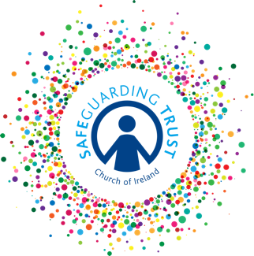

Working in partnership with parents/guardians policy template
This policy should be read in conjunction with the (parish/diocese/diocesan body/organisation)’s Communication Policy.

Working in partnership with parents/ guardians helps to safeguard children. (insert name of parish/diocese/diocesan body/organisation) sees the welfare of children as paramount and therefore seeks to form positive relationships between clergy,staff/volunteers and parents to encourage mutual trust and support.

Partnership with parents/guardians and families involves information sharing and consultation regarding all aspects of their child’s participation in (insert name of parish/diocese/diocesan body/organisation).

In order to foster positive relationships and a good working partnership between clergy/staff/volunteers and parents/guardians (insert name of parish/diocese/diocesan body/organisation) shall:
- Ensure that all clergy, staff and volunteers working with their child are introduced to parents/guardians;
- Provide parents/guardians with information leaflets on Safeguarding Trust;
- Make available to parents, via their website, all relevant policies and procedures;
- Ensure that clergy/staff/volunteers make themselves available to talk to parents/guardians informally on a regular basis;
- Allow parents the opportunity to visit their child’s activity from time to time;
- Regularly provide information on activities and events both verbally and in writing;
- Regularly provide feedback to parents on their child’s progress and participation.

The (parish/diocese/diocesan body/organisation) shall all encourage parents to:
- Ask questions about policies and procedures;
- Make suggestions or comments;
- Ask about their child’s experiences in the organisation;
- Talk to clergy/staff/volunteers about how their child is getting on in activities;
- Keep clergy, staff and volunteers informed about family events/situations that may be causing children anxiety;
- Attend events organised by the (parish/diocese/diocesan body/organisation).

It is essential that this working partnership is based on mutual respect and value so that if an occasion arises whereby a clergy, staff member or volunteer has a concern about a child, this can be discussed with parents if appropriate. (insert name of parish/diocese/diocesan body/organisation) may seek to speak with parents/guardians if a concern arises about their child or before a report is going to be made to Tusla in line with the Safeguarding Trust however, there may be circumstances in which it is not possible or appropriate to do so.

Adopted by the Select Vestry on ___________________________

