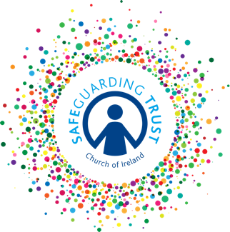
Sample consent form for social/digital media

(Insert name of group)

Social/Digital Media Consent Form

The clergy, staff and volunteers of the above group wish to use social/digital media to contact your son/daughter (aged 13 years plus) to inform him/her about the ongoing activities and special events of the group.

Consent

Name of Child: _____________________

I give permission for (insert name of group) to contact my son/daughter directly via the following methods:

Please tick the boxes below to give permission for the particular item.

Text messages

E-mails

(insert social networking site)

Contact Details (of child) – fill in if applicable

Mobile Number: _______________ E-mail: ____________________

Signed: ______________________

Date: _______________________

(This consent may be incorporated into the Membership Registration Form - see sample form in Part 8 – Appendices)

In line with Data Protection regulations, we are committed to protecting the personal information given on this form. By providing the information requested, you are giving us permission (consent) to use this information for Safeguarding, legal or regulatory purposes and we will use it for no other purpose without further consent unless mandated or required to do so under the Data Protection Act 2018 or equivalent legislation. If you have any questions about how we process your personal data, please contact a member of the Panel.

