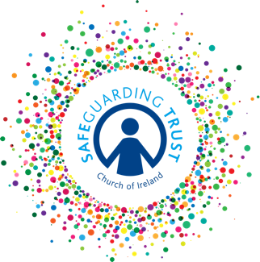

Sample consent form for photographs or recorded images

The parish of / diocese of: ____________________________________________________

recognises that the need to ensure the welfare and safety of all children. In accordance with our child protection policy, Safeguarding Trust, parents/guardians and child (of secondary level age) are asked to sign a consent form for the taking of photographs and recorded images on the understanding that photographs and recorded images may be used in a range of hardcopy, online publications and social media by the parish and/or the diocese. They may also be retained for continued use by the parish/diocese.

Parent/Guardian consent

I consent to the photographing or recording of

Name of child: ______________________________________________________________

while involved in activities run by:

Name of parish/diocese: _______________________________________________________

Yes No

Signed: _________________________________ Date: _____________________

Child’s consent (if of secondary level age)

I consent to photographing or recording of my involvement in activities run by:

Name of parish/diocese: _______________________________________________________

Yes No

I understand that my consent may be withdrawn at any time.

Signed: _________________________________ Date: _____________________

(This consent may be incorporated into the Membership Registration Form - see sample in Part 8 - Appendices)

In line with Data Protection regulations, we are committed to protecting the personal information given on this form. By providing the information requested, you are giving us permission (consent) to use this information for Safeguarding, legal or regulatory purposes and we will use it for no other purpose without further consent unless mandated or required to do so under the Data Protection Act 2018 or equivalent legislation. If you have any questions about how we process your personal data, please contact a member of the Panel.

