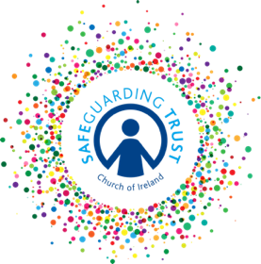
Sample Activity Consent Form

Please complete this form and return it to (insert name of group) __________________

A signed consent form is a condition of participation in this activity for those under the age of 18.

Personal Details

Name of Child: ___________________________________________________________

Age: ________________________ Date of Birth: ____________________________

Parent’s emergency contact number: Mother - ________________________________

Father - ________________________________

I am willing for (insert child’s name) __________________ to participate in (insert details of activity) and confirm that he/she is willing to participate as fully as possible.

Furthermore, I permit (insert child’s name) _________________ to travel on transport that has been designated as official for the purpose of this event.

Signed: _______________________ Date: ____________________

Medical Details

Please indicate if your child:
- Has any allergies - __________________________________________________

- Is taking any medication - ____________________________________________

- Has any special needs - _____________________________________________

I give permission for basic first aid to be administered to my son/daughter. YES/NO

In the case of an emergency, clergy, staff and volunteers will do everything reasonable to contact the parent/guardians named above. In circumstances where medical treatment is required immediately and where it is not possible to contact those named on this form, I authorise the leader in charge of the group to refer my son/daughter to a medical practitioner or emergency services on my/our behalf and to sign on my behalf any written consent required in the event of a life-threatening injury/condition.

Signed: ______________________________ Date: ______________________

Consent must be provided by the person with parental responsibility.

In line with Data Protection regulations, we are committed to protecting the personal information given on this form. By providing the information requested, you are giving us permission (consent) to use this information for Safeguarding, legal or regulatory purposes and we will use it for no other purpose without further consent unless mandated or required to do so under the Data Protection Act 2018 or equivalent legislation. If you have any questions about how we process your personal data, please contact a member of the Panel.

