Internal Report Form
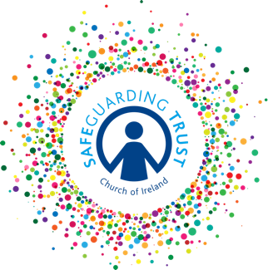
(To be used by either a bishop, clergy, staff member, volunteer or a panel member)

You may not be able to complete all of the fields in this form and not all sections will be relevant to a particular concern.

NB A bishop, clergy, staff member or volunteer should, in the first instance, report to a panel member who will report to a statutory agency.

Name of child

Age Date of birth

Address and phone number

Names of parents or carers

Address if different from above

What is the nature of the concern?

If a child has made a disclosure of abuse, state the name of the person he/she spoke to with the date, time and place

1

If a child has made a disclosure of abuse, record as precisely as possible what the child actually said

If an adult has expressed concern in relation to the safety of a child, record if he/she is expressing his/her own worries or passing on those from another adult. Record the concerns and ask him/her to confirm that the details as written are correct.

Have possible signs or indicators of harm been identified? YES/NO

If yes, please outline below

Record the name(s) of the person(s) alleged to have harmed the child:

Signed by bishop/clergy/staff member/volunteer

Date
FOR PANEL USE ONLY
Report received by

Signed Date

2

