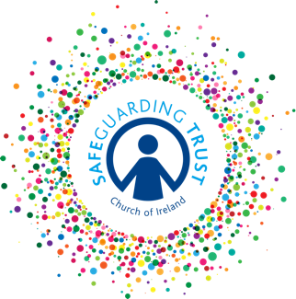
Declaration of Acceptance of Safeguarding Trust

Parish of ……………………………………………………………………………………….

Declaration

I have attended a training event on (insert date) _____________________ at (insert venue) ________________ which has introduced me to the Church of Ireland Safeguarding Trust and the recommended procedures to be followed when working with children have been explained to me.

I acknowledge receipt of the relevant sections of Safeguarding Trust and declare I will uphold the same in the position I have accepted with (name of group/parish)

I further state that I shall at all times exercise reasonable care for any children in my charge.

Name (print)

Signed

Date

NB This declaration is to be retained by the parish panel.

In line with Data Protection regulations, we are committed to protecting the personal information we hold on you. By providing the information requested, you are giving us permission (consent) to use this information for Safeguarding, legal or regulatory purposes and we will use it for no other purpose without further consent unless mandated or required to do so under the Data Protection Act 2018 or equivalent legislation. If you have any questions about how we process your personal data, please contact a member of the Panel.

